**WEB X Lab Exp 1**

Sahil Kanolkar Vu4f2122099 Div: B Batch: A

**Aim:** Study web analytics using open source tools like Matoma, Countly or plausible.

Introduction:

Matomo, formerly known as Piwik, is a downloadable, Free web analytics software platform. It provides detailed reports on your website and its visitors, including the search engines and keywords they used, the language they speak, which pages they like, the files they download and so much more. Matomo (Piwik) aims to be an open source alternative to Google Analytics. Matomo is PHP MySQL software which you download and install on your own webserver.

When you use the Matomo (Piwik) JavaScript Tracker Matomo will by default track the following information.

* User IP address (see also: IP anonymisation)
* Optional User ID
* Date and time of the request
* Title of the page being viewed (Page Title)
* URL of the page being viewed (Page URL)
* URL of the page that was viewed prior to the current page (Referrer URL)
* Screen resolution being used
* Time in local user’s timezone
* Files that were clicked and downloaded (Download)

Matomo is developed by a team of international developers and runs on a PHP/MySQL webserver. It has been translated into 54 languages. As of July 2022, Matomo was used by over a million websites, representing over 2% of all websites with known traffic analysis tools and 6% of all top 10k global websites.

Features

* Self-Hosting: Matomo allows users to host the analytics platform on their own servers. This provides control over data and addresses privacy concerns, making it an attractive option for those who prioritize data sovereignty.
* Customization: Users can customize Matomo to track specific goals and metrics relevant to their business. This includes tracking e-commerce transactions, form submissions, and other key interactions on the website.
* User Privacy: Matomo places a strong emphasis on user privacy. It offers features such as anonymizing IP addresses, honoring "Do Not Track" settings, and providing tools for GDPR (General Data Protection Regulation) compliance.
* Open Source: Being an open-source platform, Matomo allows users to access and modify its source code. This fosters a community of developers contributing to the improvement and customization of the platform.
* Dashboard and Reporting: Matomo provides a user-friendly dashboard for visualizing analytics data. Users can create customized reports, monitor key performance indicators (KPIs), and gain insights into user behavior.
* Real-Time Analytics: Matomo offers real-time analytics, allowing users to monitor website activity as it happens. This is useful for assessing the immediate impact of changes or marketing campaigns.
* Extensibility: Matomo supports various plugins and extensions, allowing users to extend the platform's functionality. This can include integrations with other tools and platforms.

It's important to note that software and platforms can evolve, and there may have been updates or changes to Matomo since my last knowledge update. For the latest and most accurate information, it's recommended to visit the official Matomo website or refer to their documentation.

Matomo web analytics is designed to cater to a diverse audience, including individuals, businesses, and organizations that seek insights into their website's performance, user behavior, and overall online presence. The primary audience for Matomo includes:

* Website Owners and Operators:

Small, medium, and large businesses that maintain an online presence.

Individual website owners or bloggers seeking to understand their audience and optimize content.

* Digital Marketers:

Marketing professionals and teams looking to assess the effectiveness of online campaigns.

Those interested in tracking conversions, click-through rates, and other marketing-related metrics.

* E-commerce Platforms:

Online retailers aiming to monitor and improve the user experience on their e-commerce websites.

Businesses tracking product performance, sales, and customer behavior.

* Web Developers and IT Professionals:

Developers who prefer self-hosted analytics solutions and want to customize tracking features.

IT professionals interested in maintaining control over analytics data for privacy and security reasons.

* Data Privacy Advocates:

Organizations and individuals with a focus on data privacy and compliance with regulations like GDPR.

Users who want to host their analytics platform to ensure full control over their data.

* Educational Institutions:

Universities, colleges, and research institutions that need analytics solutions for their websites.

Educational websites and platforms seeking insights into user engagement.

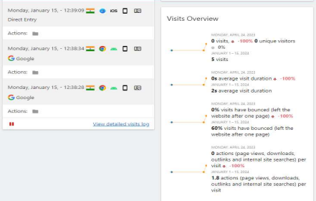



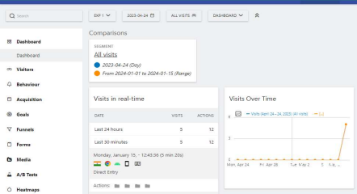

Comparison:

It's important to note that the choice of an analytics tool depends on factors such as individual preferences, technical expertise, budget constraints, and specific business requirements. Users should carefully evaluate the features and capabilities of Matomo in comparison to other tools to determine which solution aligns best with their needs. Additionally, the landscape of web analytics tools may have evolved since my last knowledge update in January 2022, so checking the latest information and user reviews is advisable.

Additionally, Matomo provides many advantages over Google Analytics: ability to get Form Analytics, Video Analytics, Heatmaps of your pages, Session Recording, Custom Branding, 100% un-sampled reports, open source “Freedom” software, and more.

Matomo also protects your visitor privacy with advanced privacy controls. When using Matomo for Web Analytics, you ensure that your visitors behaviour on your website(s) is not shared with advertising companies or any other third party.

Conclusion: Thus we have successfully studied and implemented web analytics using open source tool - Matomo.